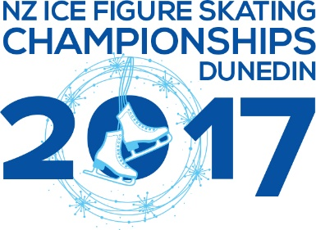
Unofficial Practice Confirmation /Payment Form

SKATER/ TEAM NAME: ______________________________
EMAIL: _______________________________
MOBILE: _______________________________
UNOFFICAL PRACTICE CONFIRMATION
Date | Time | Grade | PRICE per person/team | Tick Sessions | Sub-Total
Tuesday 3 Oct | 4:00pm – 4:50pm | Juvenile & Basic Novice A | $27.50
 | 4:50pm – 5:40pm | Basic Novice B | $27.50

Wednesday 4 Oct | 2:00pm – 2.50pm | Juvenile & Adult | $27.50
 | 2:50pm – 3:40pm | Basic Novice A | $27.50
 | Ice groom
 | 3:55pm – 4:45pm | Basic Novice B | $27.50
 | 4:45pm – 5:35pm | Advanced Novice, Junior & Senior | $27.50
 | Ice groom
 | 5:50pm – 6:20pm | Pairs, Dance | $50 per couple
 | 6:20pm – 6:45pm | Synchro Team – Black Ice | $150 per team
 | 6:45pm – 7:10pm | Synchro Team – Cutting Edge | $150 per team

Thursday 5 Oct | 12:00pm – 12:25pm | Synchro Team – Black Ice | $150 per team
 | 12:25pm – 12:50pm | Synchro Team – Cutting Edge | $150 per team
 | Ice groom
 | 1:05pm – 1:45pm | Advanced Novice, Junior & Senior | $22.50
 | 8:00pm – 8:50pm | Advanced Novice, Junior & Senior | $27.50
 | 8:50pm – 9:40pm | Adult | $27.50

Friday 6 Oct | 12:00pm – 12:25pm | Synchro Team - Momentum | $150 per team
 | Ice groom
 | 12.40pm – 1.30pm | Adult Bronze / Silver | $27.50
 | 1:30pm – 2.20pm | Adult Silver/Gold | $27.50

Saturday 7 Oct | 12:00pm -12:50pm | Adult | $27.50
 | 1:00pm -1:50pm | Synchro Team - Momentum | $280 per team
 | 4:45pm – 5:10pm | Synchro Team - Momentum | $150 per team
 | 5:10pm – 5.35pm | Synchro Team - Spectrum | $150 per team
 | Ice groom
 | 5:50pm – 6.40pm | Adult Bronze / Silver | $27.50
 | 6:40pm – 7:30pm | Adult Silver/Gold | $27.50
 |  |  | TOTAL

PLEASE MAKE PAYMENT TO DUNEDIN ICE SKATING CLUB 03 1732 0051449 00
PLEASE PUT REFERENCE: Skaters Surname
CODE: Practice
Please scan and email this order along with proof of payment to nationals2017@disc.org.nz OR sue.abr@xtra.co.nz by Sunday 1 October

